Protect Australians from Unsafe E-Bikes

Join the campaign to reverse unsafe imports and demand safer roads.

What Changed? Take Action

In 2021, e-bikes were exempted from the Motor Vehicle Standards Act. This opened the door to unsafe imports flooding the mL market.
Copy our template letter and send it to your MP today.
Together we can restore safety standards and protet our communities.

Send a Message to your Federal Member
Download the template letter .
https://ebike-safety-campaign.netlify.app/ r..»-X.�

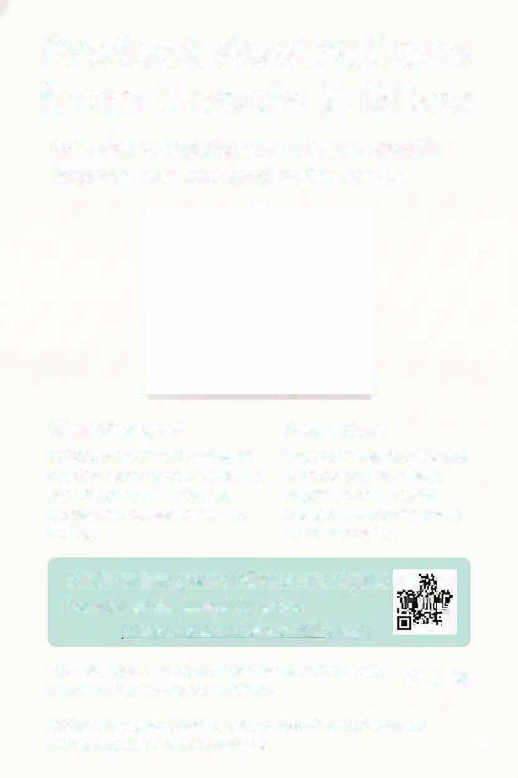
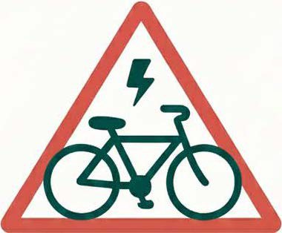

Share the campaign on Social Media
't# f @

